Q1.Let x = $√3$ + $√5$ and y = $√8$+ $√2$. Which is greater?
A.x > y
B.y > x
C.x = y
D.Cannot be determined
Ans:B
Exp:The solution is
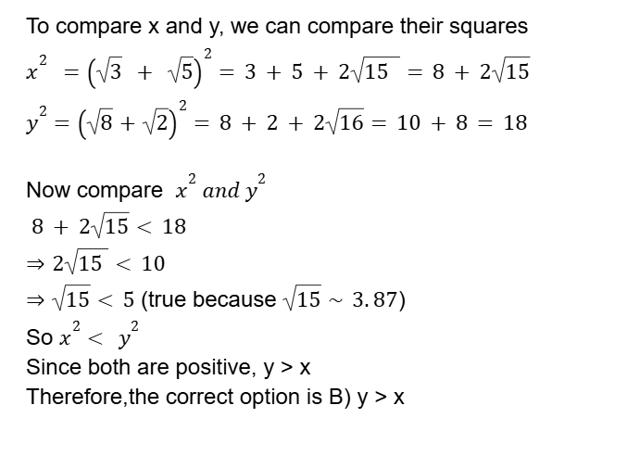
Subject:Maths > Advance Maths > Number System > Surds
Difficulty:Medium

Q2.The number of red, blue, and green marbles in a bag is in the ratio 3:4:6. If 20 red marbles, 15 blue marbles, and an unknown number of green marbles are added to the bag, the ratio becomes 4:5:7. Determine the number of green marbles added ?
A.3
B.5
C.7
D.9
Ans:B
Exp:The solution is
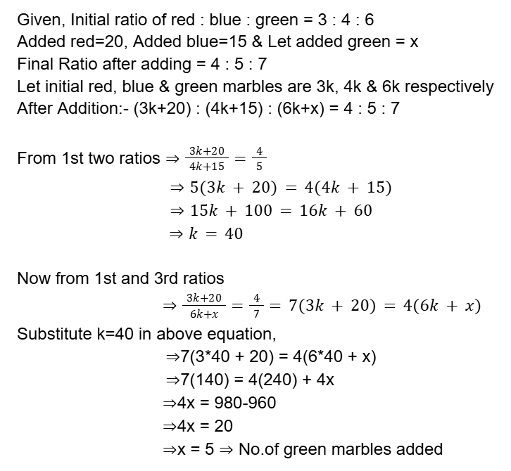
Subject:Maths > Arithmetic > Ratios
Difficulty:Medium

Q3. Evaluate the continued fraction:X = 2 $+\frac{1}{3+\frac{1}{4+\frac{1}{2}}}$
A.$\frac{67}{29}$
B.$\frac{41}{17}$
C.$\frac{45}{19}$
D.$\frac{47}{20}$
Ans:A
Exp:The solution is
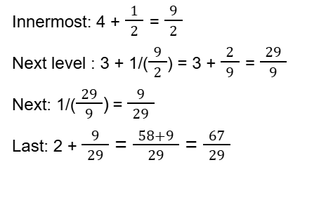
Subject: Maths > Advance Maths > Simplifications
Difficulty:Easy

Q4.A and B invest ₹40,000 and ₹60,000 respectively in a business. What is A’s share in a profit of ₹50,000?
A.₹15,000
B.₹20,000
C.₹25,000
D.₹30,000
Ans:B
Exp:The solution is
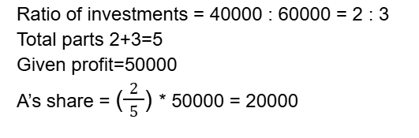
Subject:Maths > Arithmetic > Partnership
Difficulty:Easy

Q5.A and B contribute to a business investment in the ratio 3:5. They earn a profit of ₹64,000. A is a working partner and receives 10% of the profit extra. What is A’s total share?
A.₹25,600
B.₹28,000
C.₹30,400
D.₹32,000

Ans:B
Exp:The solution is
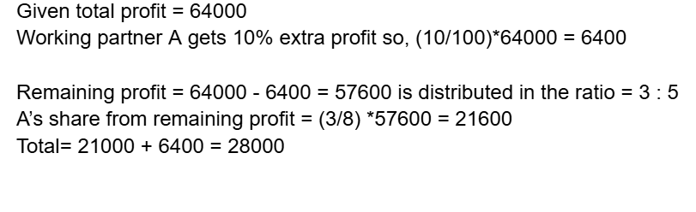
Subject:Maths > Arithmetic > Partnership
Difficulty:Medium

Q6.In a team of 75 employees, the average monthly sales per employee is ₹1.8 lakh. If 30 junior employees average ₹1.2 lakh each, what is the average monthly sales figure (in ₹ lakh) for the senior employees?
A.2.2 lakh
B.2.4 lakh
C.2.7 lakh
D.2.1 lakh
Ans:A
Exp:The solution is
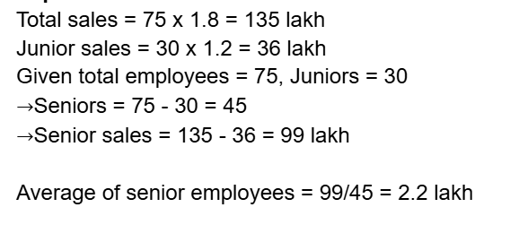
Subject: Maths > Arithmetic > Averages
Difficulty:Easy

Q7.The price of petrol shot up by 5%. Before the hike, the price was ₹82 per litre. A man travels 3045 km every month and his car gives a mileage of 15 km per litre. What is the increase in the monthly expenditure (to the nearest ₹) on the man's travel due to the hike in the petrol price?
A.₹820
B.₹832
C.₹845
D.₹850
Ans:B
Exp:The solution is
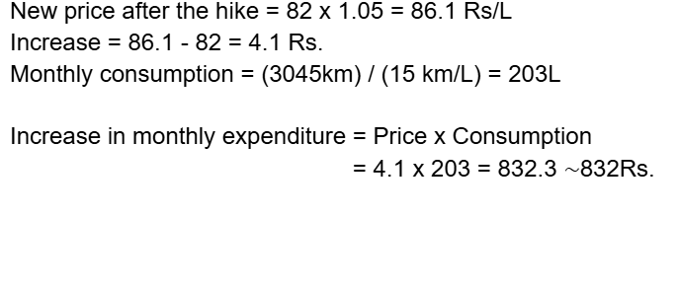
Subject:Maths > Arithmetic > Percentages
Difficulty:Medium

Q8.Acompany placed an order for 20 high-end laptops and some quantity of standard desktops. The price of a high-end laptop was 5 times that of a standard desktop. Due to a mistake, the number of laptops and desktops was interchanged in the delivery. This caused the total bill to increase by 80%. What was the ratio of the number of high-end laptops to standard desktops in the original order?
A.1:2
B.2:1
C.1:5
D.2:5
Ans:D
Exp:The solution is
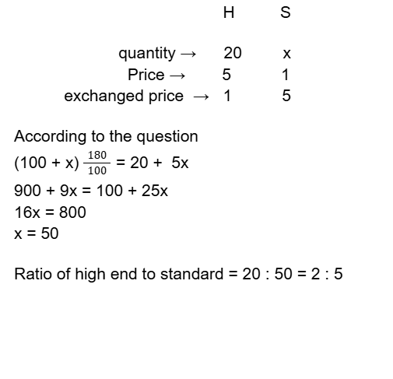
Subject: Maths > Arithmetic > Percentages
Difficulty:Hard

Q9. Find the compound interest on ₹8,000 at 12% per annum for 3 years 4 months, compounded annually.
A.₹3,000
B.₹3,400
C.₹3,689
D.₹3,600
Ans:C
Exp:The solution is
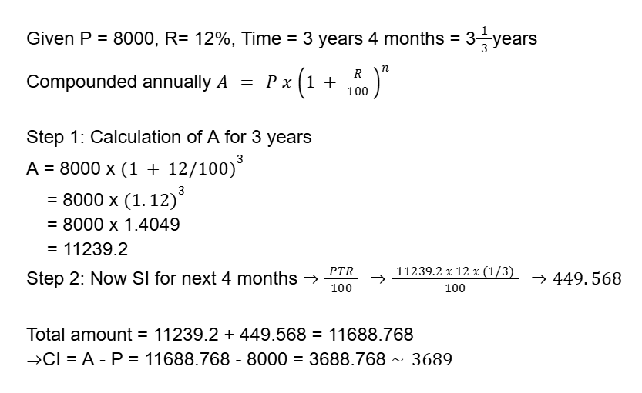
Subject:Maths > Arithmetic > Compound Interest
Difficulty:Medium

Q10.A candy shop owner buys three kinds of candies: red, blue, and green. Red candies are purchased at 3 for ₹15, blue candies at 4 for ₹18, and green candies at 5 for ₹22. He mixes them in the ratio 1:1:2. He sells all the mixed candies at 2 for ₹10. What is his profit or loss percentage?
A.20% profit
B.9.29% profit
C.10% loss
D.No profit no loss
Ans:B
Exp:The solution is
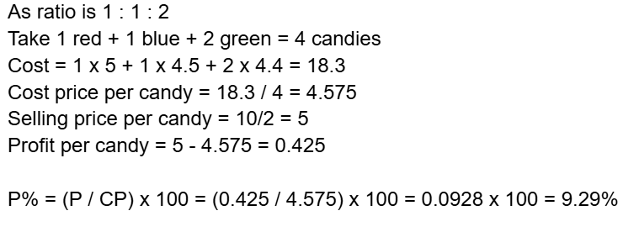
Subject: Maths > Arithmetic > Profit Loss
Difficulty:Medium

Q11.The ratio of boys to girls in a school is 7:5. If 20 more girls join the school, the new ratio of boys to girls becomes 7:6. What is the total number of students in the school initially?
A.200
B.240
C.300
D.360
Ans:B
Exp:The solution is
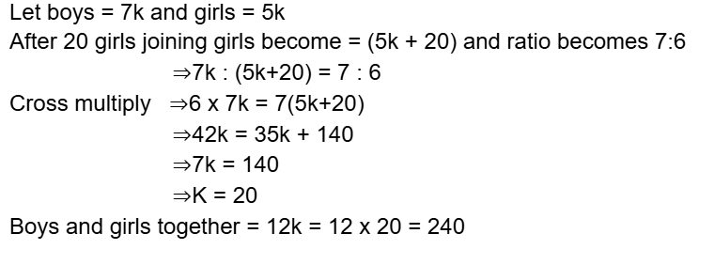
Subject:Maths > Arithmetic > Ratios
Difficulty:Easy

Q12.A, B, and C are capable of completing a job in 30, 45, and 90 days, respectively. A works every day, while B and C join A every fifth day. How long will it take to finish the task?
A.25 days
B.23 days
C.18 days
D.16 days
Ans:A
Exp:The solution is
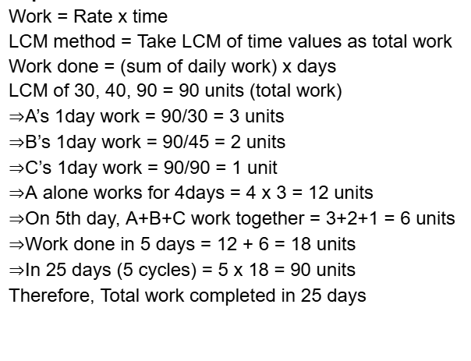
Subject: Maths > Arithmetic > Time and Work
Difficulty:Easy

Q13.A 100-litre solution contains acid and water in the ratio 3:2. Some quantity of this solution is removed and replaced with pure acid. If the final ratio of acid to water becomes 7:3, how many litres of solution were replaced?
A.35 litres
B.25 litres
C.45 litres
D.50 litres
Ans:B
Exp:The solution is
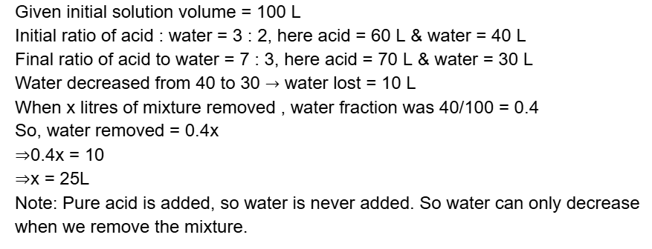
Subject:Maths > Arithmetic > Mixtures
Difficulty:Medium

Q14.The ratio of the efficiencies of two workers, P and Q, is 5 : 2. If P can complete a project in 12 days, how many days will Q take to complete the same project alone?
A.24 days
B.30 days
C.18 days
D.35 days
Ans:B
Exp:The solution is
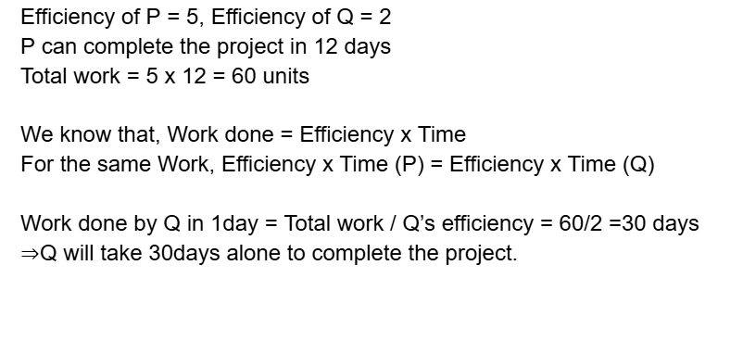
Subject:Maths > Arithmetic > Time and Work
Difficulty:Medium

Q15. A car starts from point P on a circular track and an SUV starts from point Q, which is 600 metres ahead of P in the direction of motion. The car’s speed is 15 m/s, and the SUV’s speed is 10 m/s. The circumference of the track is 1.5 km. How much distance will the car have travelled when it first overtakes the SUV?
A.900 m
B.1200 m
C.1500 m
D.1800 m
Ans:D
Exp:The solution is
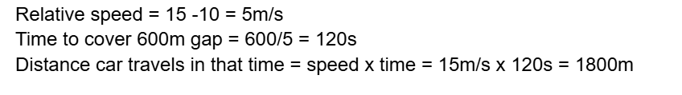
Subject:Maths > Arithmetic > Races
Difficulty:Medium

Q16.A circular park having a radius of 14 m. If a 1.5 m wide path is built around it, what is the approximate area of the path?
A.139 m²
B.135 m²
C. 150 m²
D. 142 m²
Ans:A
Exp:The solution is
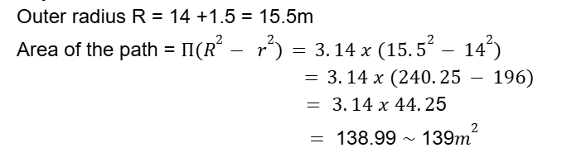
Subject:Maths > Advance Maths > Mensuration 2D
Difficulty:Medium

Q17. What is ($\frac{5π}{4}$) radians in degrees?
A.225°
B.180°
C.240°
D.360°
Ans:A
Exp:The solution is
Subject:Maths > Advance Maths > Geometry > Lines and Angles
Difficulty:Easy

Q18.The line y = –x + 4 passes through which of the following points?
A.(2, 2)
B.(4, –4)
C.(5, 1)
D.(3, 6)
Ans:A
Exp:The solution is
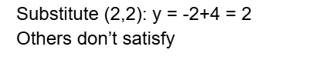
Subject:Maths > Advance Maths > Coordinate Geometry
Difficulty:Easy

Q19.What is the central angle of a sector with an arc length of 10 cm in a circle of radius 5 cm?
A.6 radians
B.3 radians
C.2 radians
D.4 radians
Ans:C
Exp:The solution is
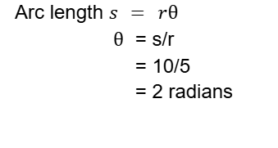
Subject:Maths > Advance Maths > Mensuration 2D
Difficulty:Easy

Q20.If tan(90° – A) = $√3$, What is sin A?
A.$\frac{1}{2}$
B.$\frac{√3}{2}$
C.$\frac{1}{√2}$
D.1
Ans:A
Exp:The solution is
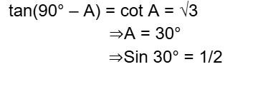
Subject:Maths > Advance Maths > Trigonometry
Difficulty:Easy

Q21.If x = $√7$, determine the value of x + $\frac{1}{x}$.
A.$\frac{8√7}{7}$
B.$\frac{7√7}{8}$
C.$\frac{8√7}{9}$
D.$\frac{9√7}{7}$
Ans:A
Exp:The solution is
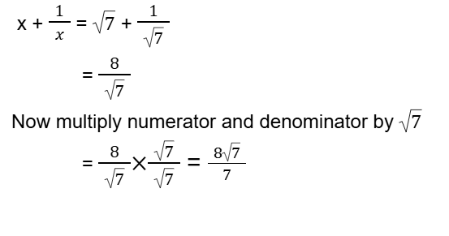
Subject:Maths > Advance Maths > Algebra
Difficulty:Easy

Q22.Two triangles are similar with sides in the ratio 3:5. What is the ratio of their areas?
A.5:3
B.9:25
C.25:9
D.3:5
Ans:B
Exp:The solution is

Subject:Maths > Advance Maths > Geometry > Triangles
Difficulty:Easy

Q23. If x = $√\frac{2+√3}{2-√3}$, then determine the value of x² + x – 9?
A.2$√3$
B. 3$√3$
C. 4$√3$
D. 5$√3$
Ans:D
Exp:The solution is
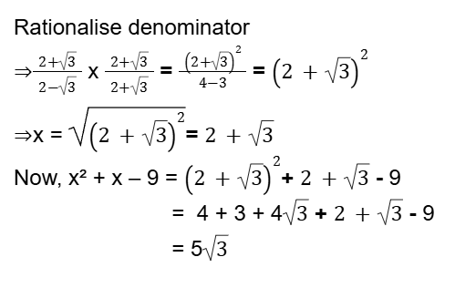
Subject:Maths > Advance Maths > Algebra
Difficulty:Medium

Q24.The angles of a cyclic quadrilateral are in the ratio 1:2:3:4. What is the measure of the smallest angle?
A.36°
B.45°
C.72°
D.90°
Ans:A
Exp:The solution is
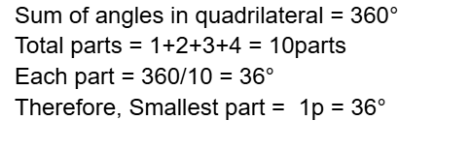
Subject:Maths > Advance Maths > Geometry > Lines and Angles
Difficulty:Easy

Q25. If sec A = $\frac{13}{5}$ and A is acute, find sin A.
A.$\frac{12}{13}$
B.$\frac{5}{13}$
C.$\frac{13}{12}$
D.$\frac{5}{12}$
Ans:A
Exp:The solution is
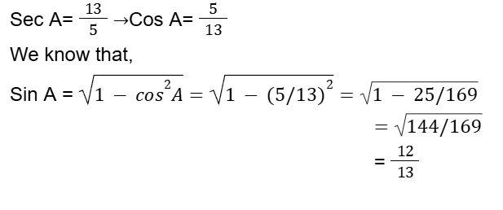
Subject:Maths > Advance Maths > Trigonometry
Difficulty:Easy

